**Topic:** Meloxicam and Alcohol in 2023 – Vigoursoul

**Focus keyword:** Meloxicam and Alcohol

**Meta Title:** Meloxicam and Alcohol in 2023 – Vigoursoul

**Meta Description:** Many individuals combine meloxicam and alcohol without thinking twice about it. However, combining these two drugs is risky.

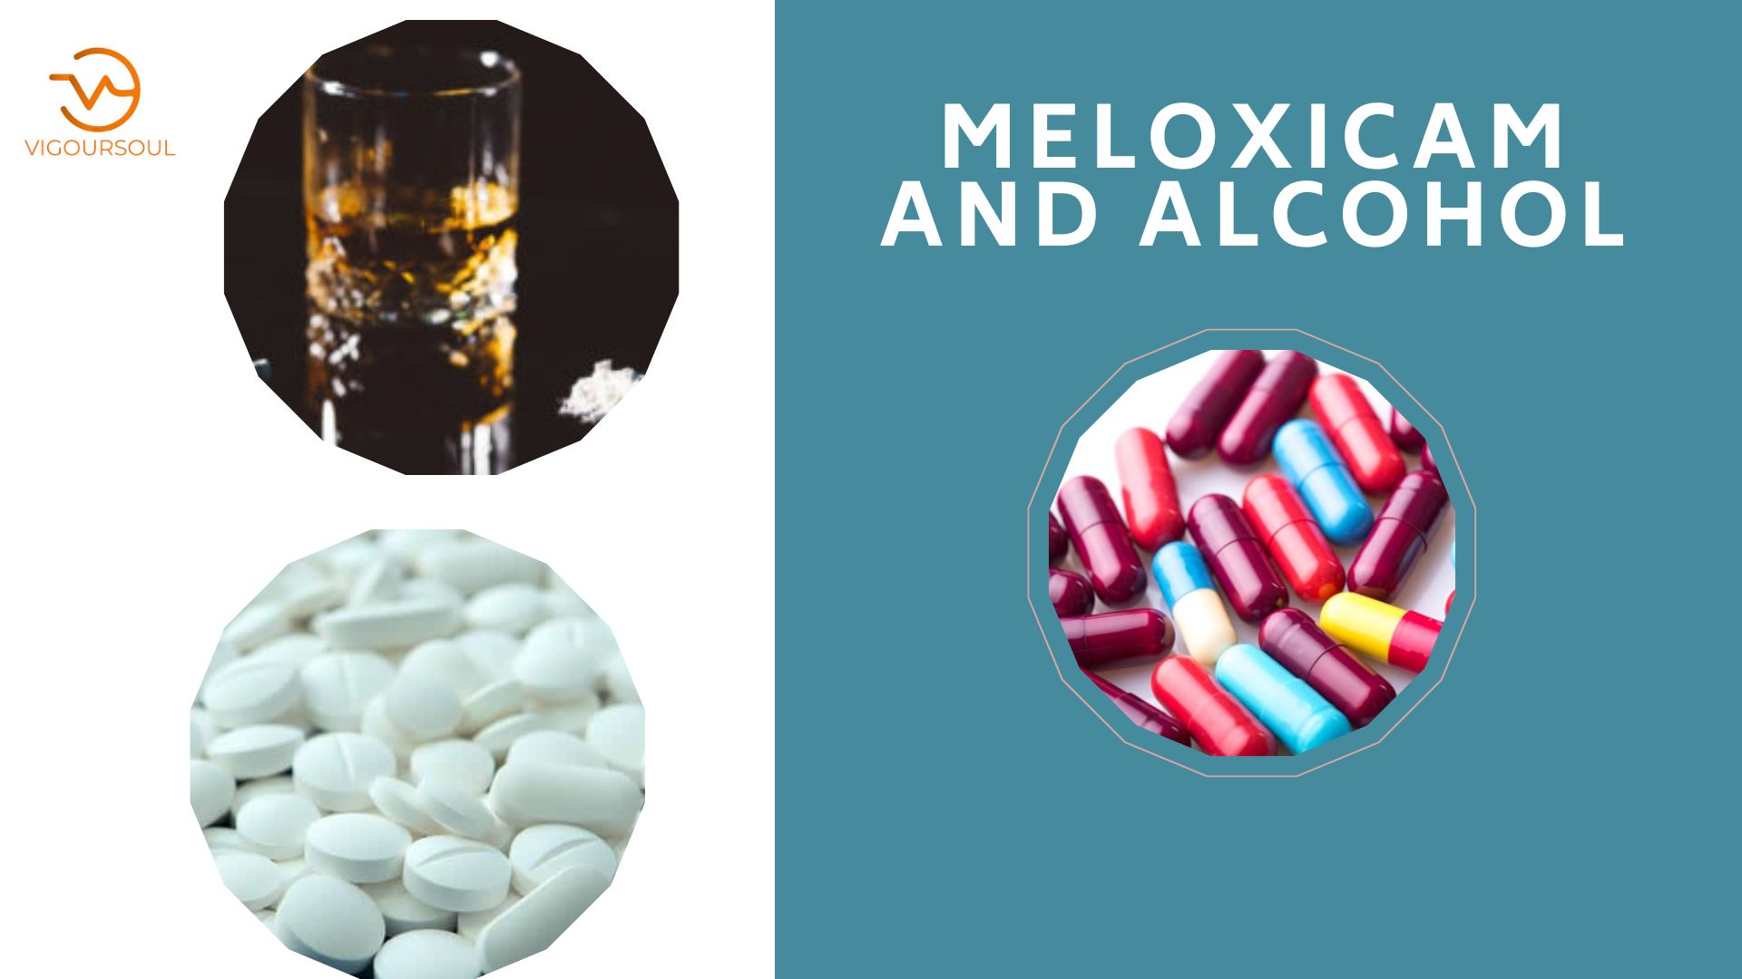Meloxicam-induced gastrointestinal bleeding can be exacerbated by alcohol. If you develop symptoms of bleeding in your stomach or intestines, contact your doctor right once. [Meloxicam and Alcohol](https://en.wikipedia.org/wiki/Meloxicam) include black, bloody, or tarry stools, as well as coughing up blood or vomit resembling coffee grounds.

**Table content:**

**What is Meloxicam?**

Meloxicam, as previously stated, is a no steroidal anti-inflammatory medication (NSAID). This drug is often used to treat the symptoms of arthritis. Meloxicam treats illnesses such as arthritis by inhibiting particular enzymes, resulting in decreased levels of inflammation overall.

**Meloxicam 15 mg and Alcohol:**

Alcohol use is strictly prohibited when using meloxicam or any other NSAID. Doctors strongly advise avoiding drinking alcohol while using meloxicam. Combining these drugs dramatically raises the risk of GI disorders, including GI bleeding.

**Meloxicam 7.5 and Alcohol:**

Meloxicam-induced gastrointestinal bleeding can be exacerbated by alcohol. If you develop signs of bleeding in your stomach or intestines, contact your doctor right once. This includes black, bloody, or tarry stools, as well as coughing up blood or vomit resembling coffee grounds.

**Meloxicam 7.5 mg tablet and Alcohol:**

Is it illegal to drink alcohol when taking meloxicam? Alcohol use is strictly prohibited when using meloxicam or any other NSAID. Doctors strongly advise avoiding drinking alcohol while using meloxicam. Combining these drugs dramatically raises the risk of GI disorders, including GI bleeding.

**Meloxicam and Alcohol Side Effects:**

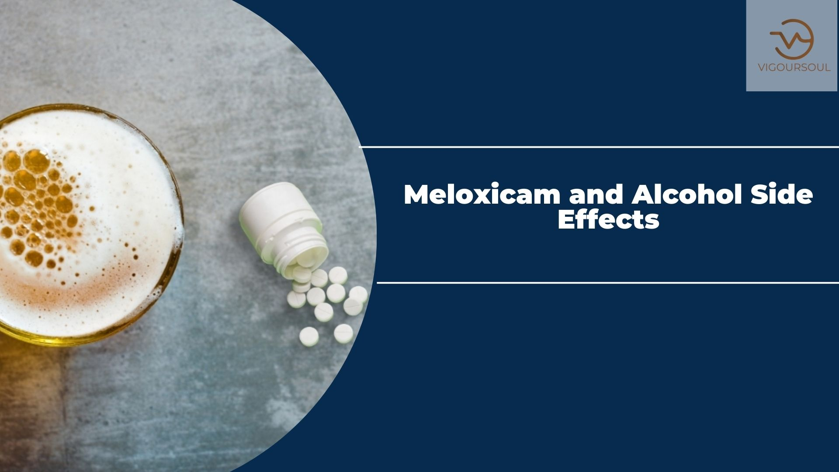

Taking meloxicam exactly as advised can result in the development of potentially fatal cardiac and gastrointestinal problems. However, adding alcohol to the mix raises the risk of major health problems arising.

**Blood Pressure Is Excessive:**

* One of the lesser-known negative effects of NSAIDs like meloxicam is that it can develop or aggravate hypertension. This has an impact on everything from your heart to your kidneys and even your eyes. Alcohol has also been linked to an increase in acute blood pressure (scientists believe this is because alcohol stimulates adrenal glands which result in your heart working harder and pumping more blood more quickly).
* sky of major health problems arising. Although the effects of alcohol on blood pressure are quickly reversible and dissipate within a few hours of ingestion, the overlap can be fatal on the body when combined with meloxicam's long half-life. The accompanying cardiovascular stress establishes the foundation for a stroke or heart attack, both of which can be deadly.

**Ulceration of the Stomach:**

* These types of no steroidal anti-inflammatory medicines (NSAIDs) are known to irritate the digestive tract. Constipation, diarrhea, stomach discomfort, and vomiting are all pretty frequent symptoms. The development of stomach ulcers is a far less common (and far more serious) gastrointestinal side effect. These are painful ulcers on the stomach lining that can obstruct digestion and cause a lot of pain.
* A stomach ulcer can also be exacerbated by excessive drinking. Alcohol achieves this by increasing the quantity of stomach acid produced, which can cause discomfort. When alcohol and meloxicam are combined, they not only increase the probability of developing an ulcer, but they can also aggravate the disease, leading to the potentially fatal complication of a bleeding ulcer. This illness is characterized by sticky, black or dark red faces, bloody vomit, and anemia.

**Kidney Issues:**

* NSAIDs have been linked to two forms of acute renal (kidney) injury, as well as chronic kidney injury or failure. This is due to the fact that NSAIDs' anti-inflammatory effect might impede the formation of renal prostaglandins, which are crucial lipids that assist maintaining proper kidney function. Because the kidneys produce fewer of them, these tiny bean-shaped organs may have a more difficult job managing the body's salt and water balance (among other things). This might result in fluid retention, which can have a cascading impact on various key organs and physical processes in addition to the kidneys. The longer an NSAID, in this case meloxicam, is used, the higher these risks become. Alcohol exacerbates these problems by interfering with your kidney's capacity to control fluid levels in the body. Alcohol exacerbates these problems by interfering with your kidney's capacity to control fluid levels in the body.

**Why are Mixing Meloxicam and Alcohol Dangerous?**

* Because meloxicam is a non-narcotic anti-inflammatory medicine, many people may have no problem consuming a couple glasses of wine with their regular dosage. However, combining meloxicam and alcohol can result in a variety of harmful health effects. The combination of the two medications has the potential to result in life-threatening gastrointestinal difficulties as well as cardiac complications such as heart attacks or strokes.
* Many individuals are aware of the need of eating before taking an NSAID. This is due to the fact that eating allows food to lining the stomach, reducing unfavorable gastrointestinal (GI) symptoms. Given this, it's clear that meloxicam has the potential to cause GI problems. Doctors, on the other hand, take this into account when prescribing the prescription and offer patients safe amounts based on their medical history and overall condition.
* Individuals who consume alcohol while taking meloxicam against their doctor's advice put themselves at increased risk of suffering GI complications such as upper gastrointestinal hemorrhage. This is due to the fact that the combination of alcohol and meloxicam places additional strain on an individual's stomach lining, resulting in stomach ulcers and gastritis, which can lead to upper GI bleeding.

**Meloxicam and Alcohol Overdose:**

An overdose can occur when a person consumes too much meloxicam or combines the medicine with alcohol. Meloxicam is prescribed by weight, which means that if a person loses a substantial amount of weight and continues to take the same quantity of meloxicam, they may overdose. Furthermore, the combination of alcohol and meloxicam may have life-threatening side effects, leading to an overdose.

The symptoms of meloxicam overdose include:

* Pain in the chest or throat
* Severe decrease in energy
* Blue coloration in the skin, lips, or fingernails
* Trouble breathing or rapid heart rate
* Seizures
* Coma

**FAQS**

**What is Meloxicam and what does it treat?**

Meloxicam is a no steroidal anti-inflammatory medicine (NSAID) that is commonly prescribed to individuals suffering from arthritis, osteoarthritis, inflammation-related discomfort and swelling, and juvenile rheumatoid arthritis. It acts by blocking the enzymes that cause inflammation.

**How dangerous is Meloxicam?**

Meloxicam is an NSAID, which is known to raise the risk of heart attack and stroke. Meloxicam may potentially have a deleterious impact on gut health, resulting in ulcers, bleeding, or perforation of the gastrointestinal (GI) tract. These potentially lethal occurrences can occur at any time when using meloxicam.

**What should you not drink with Meloxicam?**

However, combining meloxicam and alcohol can result in a variety of harmful health effects. The combination of the two medications has the potential to result in life-threatening gastrointestinal difficulties as well as heart complications such as heart attacks or strokes.

**What is the Best time to take Meloxicam?**

Meloxicam is a once-daily no steroidal anti-inflammatory medication (NSAID) that can be used at any time of day. To avoid stomach trouble, take your medicine at the same time every day and with food or a meal.

**Does meloxicam help you sleep?**

Does meloxicam put you to sleep? Meloxicam does not commonly cause sleepiness. Meloxicam's most common adverse effects are abdominal pain, nausea, dizziness, and headache. Sleepiness or drowsiness following meloxicam administration could indicate a major condition, such as an overdose.

**Conclusion:**

However, combining meloxicam and alcohol can result in a variety of harmful health effects. The combination of the two medications has the potential to result in life-threatening gastrointestinal difficulties as well as heart complications such as heart attacks or strokes. Many people are aware of the importance of eating before taking an NSAID.